Name...……………………………………………………….. Index Number...…………………..

Candidate’s Signature ……….………………… Date…………………………….

**233/1**

**CHEMISTRY (THEORY)**

**PAPER 1**

**2 HOURS**

**Kenya Certificate of Secondary Education (KCSE)**

**BRISINGA JOINT EXAM**

**JUNE/JULY, 2024**

**INSTRUCTIONS TO CANDIDATES**

1. Write your name and index number in the spaces provided above.
2. Sign and write the date of examination in the spaces provided above.
3. Answer **ALL** the questions in the spaces provided in the question paper.
4. KNEC Mathematical tables and silent non-programmable electronic calculators may be used.
5. All working **MUST** be clearly shown where necessary
6. This paper consists of **13** printed pages.
7. Candidates should check the question paper to ensure that all pages are printed as indicatedand no questions are missing.
8. Candidates should answer all the questions in English.

**For Examiner’s Use Only**

|  |  |  |
| --- | --- | --- |
| **Question** | **Maximum Score** | **Candidate’s Score** |
| 1 – 29 | 80 |  |

1. Study the information in the table below and answer the questions that follow. The letters do not represent the actual symbols of the elements.

|  |  |  |  |
| --- | --- | --- | --- |
| **Substance** | **Solubility in water** | **Electrical conductivity** | |
| **Solid** | **Molten** |
| A | Insoluble | Good | Good |
| B | Soluble | Poor | Good |
| C | Insoluble | Poor | Poor |

1. Which of the substances is highly likely to be sodium chloride? Explain (2marks)

………………………………………………………………………………………………………………………………………………………………………………………………………………………………………………………………………………………………………

1. What type of bond exists in substance A? (1mark)

……………………………………………………………………………………………………………………………………………………………………………………………………

1. State a possible structure in substance C? (1mark)

……………………………………………………………………………………………………………………………………………………………………………………………………

2. The formular below represents the active ingridients in a soapless detergent and in a soapy detergent respectively.

CH3 (CH2)4 – C S3 Na+, CH3 (CH2)16COO-Na+

a) What is a detergent? (1 mk)

………………………………………………………………………………………………………

………………………………………………………………………………………………………

b) Give a reason for adding polyphosphate to the soapless detergent (2 mks)

………………………………………………………………………………………………………

………………………………………………………………………………………………………

3. Explain why sulphur is a solid while oxygen is a gas at room temperature. (2 marks)

………………………………………………………………………………………………………

………………………………………………………………………………………………………

……………………………………………………………………………………………………

4. A radioactive isotope is found to give an activity of 360 counts per second. Thirty minutes later the activity has dropped to 45 counts per second. What is the half life of the isotope

(3mks)

………………………………………………………………………………………………………………………………………………………………………………………………………………………………………………………………………………………………………………………………………………………………………………………………………………………………

5. In a reaction, 0.65 g of impure zinc oxide reacted with 100 cm3 of 0.15 M nitric (V) acid.

(a) Write equation of the reaction. (1 mark)

………………………………………………………………………………………………………

(b) Calculate percentage purity of the zinc oxide sample. (2 marks)

(Zn = 65, O = 16)

………………………………………………………………………………………………………

………………………………………………………………………………………………………

………………………………………………………………………………………………………

………………………………………………………………………………………………………

6. The set up below can be used for the laboratory preparation of product **W**.

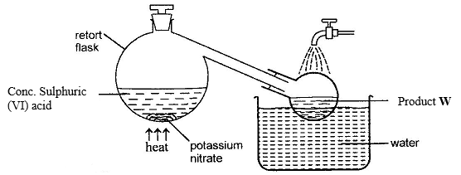

(a) Write chemical equation for the reaction that takes place in the retort flask. (2 mark)

………………………………………………………………………………………………………………………………………………………………………………………………………………………………………………………………………………………………………………………

(b) Explain why product W appears yellow in colour. How is the colour removed? (2 marks)

………………………………………………………………………………………………………

………………………………………………………………………………………………………

………………………………………………………………………………………………………

………………………………………………………………………………………………………

7. The table below shows information of four elements **A**, **B**, **C** and **D**. Study it and answer the

questions that follow. The letters do not represent the actual symbols of the elements.

|  |  |  |  |
| --- | --- | --- | --- |
| Element | Electronic arrangement | Atomic radius | Ionic radius |
| A | 2.8.2 | 0.136 | 0.065 |
| B | 2.8.7 | 0.99 | 0.181 |
| C | 2.8.8.1 | 0.203 | 0.133 |
| D | 2.8.8.2 | 0.174 | 0.099 |

(a) Which two elements have similar properties? (1 mark)

………………………………………………………………………………………………………

(b) Explain why ionic radius of B is larger than its atomic radius. (2 marks)

………………………………………………………………………………………………………

………………………………………………………………………………………………………. 8. During the extraction of copper and zinc from their ores, some of the processes include;

1. Crushing
2. . Mixing of the crushed ore with oil and water and bubbling air through it.
3. Name the process (ii) above ( 1mk)

……………………………………………………………………………………………………

(b) What is the purpose of process (ii) above? 1mk)

..........................................................................................................................................................

(c) Bronze is an alloy of copper and another metal. Identify the other metal . (1mk)

……………………………………………………………………………………………………

9. Describe how chloride ions are tested in a solution. (2 marks)

………………………………………………………………………………………………………

………………………………………………………………………………………………………

………………………………………………………………………………………………………

………………………………………………………………………………………………………

10. The empirical formula of X is CH2Br. Given that 0.235 g of X occupies a volume of 56 cm3

at 546 K and 1 atmosphere pressure, determine its molecular formula.

(H = 1.0, C = 12.0, Br = 80.0, molar gas volume at STP = 22.4 dm3) (3marks)

………………………………………………………………………………………………………

………………………………………………………………………………………………………

………………………………………………………………………………………………………

………………………………………………………………………………………………………

………………………………………………………………………………………………………

………………………………………………………………………………………………………

11. Calculate the quantity of electricity in faraday required to deposit 1mole of lead if a current of 2.0 A is passed for 15 minutes through molten lead bromide and the mass of lead deposited is 1.95g (RMM of Pb = 207) (3 marks

………………………………………………………………………………………………………

………………………………………………………………………………………………………

………………………………………………………………………………………………………

………………………………………………………………………………………………………

………………………………………………………………………………………………………

………………………………………………………………………………………………………

………………………………………………………………………………………………………

12. The set-up below was used to prepare a hydrocarbon. Study it and answer the questions that

follow.

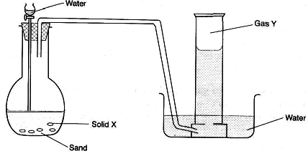

(a) Identify solid X and gas Y.

Solid X………………………………………………………………..... (1 mark)

Gas Y………………………………………………………………….... (1 mark)

(b) Write a chemical equation for the complete reaction between gas Y and exccess bromine

vapour. (1 mark)

………………………………………………………………………………………………………

13. (a) When excess chlorine gas is bubbled through cold, dilute sodium hydroxide solution, the

resulting solution acts as a bleaching agent. Using an equation, explain how the resulting

solution acts as a bleaching agent. (1 mark)

………………………………………………………………………………………………………

(b). What is observed when chlorine gas is bubbled through a solution of potassium

bromide? Explain. (2 marks)

………………………………………………………………………………………………………

………………………………………………………………………………………………………

………………………………………………………………………………………………………

………………………………………………………………………………………………………

14. (a) Explain why the pH of 1.0 M hydrochloric acid is 1 while that of 1.0 M ethanoic acid is

5.0. (1 mark)

………………………………………………………………………………………………………

………………………………………………………………………………………………………

………………………………………………………………………………………………………

(b) How can a precipitate of barium sulphate be distinguished from that of barium sulphite?

(2 marks)

………………………………………………………………………………………………………

………………………………………………………………………………………………………

………………………………………………………………………………………………………

………………………………………………………………………………………………………

15. **A**, **B**, **C** and **D** are dyes present in a mixture. In a given solvent, **C** is more soluble than **B** and **A** is more soluble than **C**. **D** is the least soluble. Draw an ascending paper chromatogram showing how they would appear when separated using the solvent. (2 marks)

………………………………………………………………………………………………………

………………………………………………………………………………………………………

………………………………………………………………………………………………………

………………………………………………………………………………………………………

………………………………………………………………………………………………………

………………………………………………………………………………………………………

………………………………………………………………………………………………………

………………………………………………………………………………………………………

16. The reaction below refers to the preparation of lead (II) sulphate starting with lead metal.

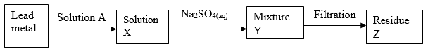

(a) Name solution A…………………………………………………………….. (1 mark)

(b) Write an ionic equation for the reaction in (a) above. (1 mark)

………………………………………………………………………………………………………

(c) Explain why it is not possible to prepare residue Z using lead metal and dilute sulphuric

acid. (1 mark)

………………………………………………………………………………………………………

………………………………………………………………………………………………………

………………………………………………………………………………………………………

………………………………………………………………………………………………………

17. An element K has atomic number 20 while element M has atomic number 8.

1. Write the electronic configuration for ions of K and M

K ………………………………….……………………………………………………(1mark)

M…………………………………………………………………………………….…(1mark**)**

1. Write the symbol of the most stable ion of K and M

K

……………………………………………………………………………………(1/2mark)

M

……………………………………………………………………………………(1/2mark)

18. (a) Distinguish between endothermic and exothermic reaction. (1 mark)

………………………………………………………………………………………………………

………………………………………………………………………………………………………

………………………………………………………………………………………………………

………………………………………………………………………………………………………

(b) Nitrogen reacts with oxygen to form nitrogen (II) oxide according to the following

reaction

N2(g) + O2(g) → 2NO(g) ∆H = +180 kJmol-1

Draw an energy level diagram for this reaction including the activation energy. (2 marks)



19. (a) When a compound T was heated, a brown gas and a residue which was yellow when hot

and white when cold were formed. Identify the:

(i) Brown gas…………………………………………………………….. (1 mark)

(ii) Residue………………………………………………………………… (1 mark)

(b) Name a suitable drying agent for ammonia gas. (1 mark)

………………………………………………………………………………………………………

20. Give the structural formula of the following organic compounds.

(a) 2-Methylbutane (1 mark)

………………………………………………………………………………………………………

………………………………………………………………………………………………………

(b) Pent-2-ene (1 mark)

………………………………………………………………………………………………………

………………………………………………………………………………………………………

21. 1003 of solution containing 112g/l of potassium hydroxide was placed in a vacuum flask and its temperature was recorded to be 180cm. When 100cm3 of 2M nitric acid at 200C was added and the mixture stirred, the highest temperature reached was 320C.

i. What is the Molarity of potassium hydroxide solution (1 mk)

………………………………………………………………………………………………………

………………………………………………………………………………………………………

1. Work out the molar enthalpy change ( $∆ H)$ of neutralization. (3 mks)

………………………………………………………………………………………………………

………………………………………………………………………………………………………………………………………………………………………………………………………………………………………………………………………………………………………………………

………………………………………………………………………………………………………

………………………………………………………………………………………………………

22. State and explain the observations that would be made when burning magnesium is lowered

into a gas jar of sulphur (IV) oxide. (3 marks)

………………………………………………………………………………………………………

………………………………………………………………………………………………………

………………………………………………………………………………………………………

………………………………………………………………………………………………………

23. A mixture contains barium sulphate, calcium chloride and dry ice. Describe how the

components can be separated. (3 marks)

………………………………………………………………………………………………………

………………………………………………………………………………………………………

………………………………………………………………………………………………………

………………………………………………………………………………………………………

24. In the redox reaction below:

2H+(aq) + Cr2O72-(aq) + 3SO2(aq) → 2Cr3+(aq) + 3SO42-(aq) + H2O(l)

Identify the reducing agent. Explain. (2 marks)

………………………………………………………………………………………………………

………………………………………………………………………………………………………

………………………………………………………………………………………………………

………………………………………………………………………………………………………

25 (a) Explain why aluminium utensils do not corrode as easily as iron utensils although

aluminium is higher than iron in the reactivity series. (1 mark)

………………………………………………………………………………………………………

………………………………………………………………………………………………………

………………………………………………………………………………………………………

………………………………………………………………………………………………………

(b) State **two** uses of aluminium other than utensils making. (2 marks)

………………………………………………………………………………………………………

………………………………………………………………………………………………………

26. The diagram below represents a set up that was used to react lithium with steam. Study and

answer the question that follows.

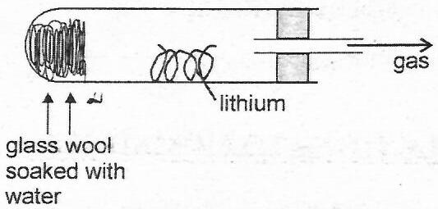

a) Write an equation for the reaction that takes place. (1 mark)

………………………………………………………………………………………………………

b) Why is it not advisable to use potassium metal in place of lithium in the above set-up? (1 mark)

………………………………………………………………………………………………………

………………………………………………………………………………………………………

c) The gas produced above is used for welding. Which other gas is combined with it? (1 mark)

………………………………………………………………………………………………………

27. Using dots (.) and crosses (×) to represent valence electrons, show bonding in:

(a) Nitrogen trifluoride (N = 7, F = 9) (1 mark)

(b) Sodium oxide (Na = 11, O = 8) (1 mark)

28 The graphs below were drawn by measuring the volume of hydrogen produced with time

when excess zinc metal in different physical states were reacted with 50 cm3 of 2 M

hydrochloric acid.

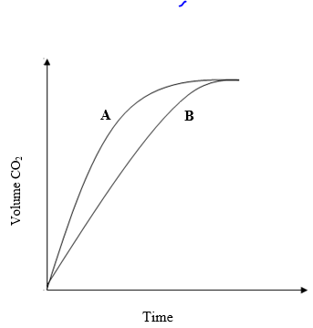

(a) Which curve corresponds to the reactions involving powdered zinc? (1 mark)

………………………………………………………………………………………………………

(b) Both curves eventually flatten out at the same level of hydrogen. Explain. (1 mark)

………………………………………………………………………………………………………

………………………………………………………………………………………………………